SYSTEM DOCUMENT

Project:
Task:

Document Version Number:
Date:
Author:

This document is intended to identify and define the solution environment, i.e. the tools you can use and the basic components you have to construct a solution from. You need to identify the capabilities of all parts that you have – both software and hardware.

The goal of this document is to know everything you need to about the system to be used for implementing the solution to the design problem.

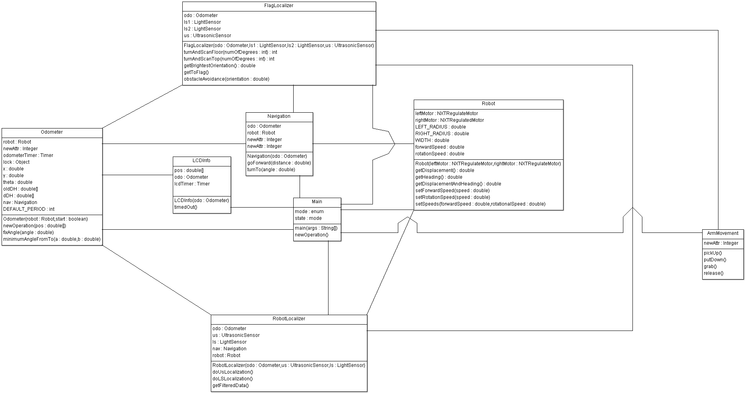
- TABLE OF CONTENTS

2.0 SYSTEM MODEL
(See UML diagram)

- HARDWARE AVAILABLE AND CAPABILITIES

Hardware Available
NXT brick
Technical specifications of the NXT Brick
- 32-bit ARM7 microcontroller @ 48 MHz (256 Kbytes FLASH, 64 Kbytes RAM)
- 8-bit AVR microcontroller (4 Kbytes FLASH, 512 Byte RAM)
- Bluetooth wireless communication (Bluetooth Class II V2.0 compliant)
- USB 1.1 full speed port (12 Mbit/s)
- 4 input ports, 6-wire cable digital platform
- 3 output ports, 6-wire cable digital platform
- 100 x 64 pixel LCD graphical display
- Power source: 6 AA batteries
Servo Motor
- Able to turn a set number of degrees, or track rotation caused by external forces.
Ultrasonic Sensor
- Measures distances between 0 and 255 cm, +/- 3 cm.
Light Sensor
- Measures a normalized light value between 0 and 1023, or in percentage form (0-100%).
Sound Sensor
- Measures sound intensity in decibels from 0 to 90 dB
Touch Sensor
- Has a button that detects when it is being pressed.
Hardware constraints

- The Lego components are of limited usability due to their unyielding structure.
- The communication between bricks is not at all complex because there is memory limitation on the brick we are using.
- In hardware we are basically using two NXT bricks which would communicate between themselves. We would be using 3 ultrasonic sensors, 1 at the front and 2 at the sides for obstacle avoidance. We have 2 light sensors, one at the back for localization and one in front for beacon detection. We are using 6 motors.
- The robot is heavy so to support the base, the back of the robot is being supported by a ball (normal wheels don’t stand the weight) for 360º motion. The ball not always provides a smooth movement because of particles attached to the floor.

- SOFTWARE AVAILABLE AND CAPABILITIES

Eclipse offers some advantages over a simple text editor such as coloured syntax as well as making it easier to upload code to the robot (as opposed to uploading via the command prompt). We use Eclipse as our IDE as well as the leJOS library. There exist a large number of other libraries that are used by other languages, such as python, but as we used Java and leJOS in the labs, and, as a result, have more experience with it, it made more sense to continue using it for the purpose of our robot.

4.0 COMPATIBILITY
The version of leJOS that is being used in both NXT bricks is 0.9.1. The NXT bricks will communicate via Bluetooth (using the RemoteNXT library). The Bluetooth communication between the two is expected to have a larger drain on the battery, but implementing it frees up two sensor ports.

5.0 REUSABILITY
We will try to reuse and implement, after some manipulation, a number of the classes we had developed throughout the early part of the semester over the course of our labs (e.g. Odometer, Navigation, TwoWheeledRobot, LCDInfo, etc.).

6.0 STRUCTURES

Software: We will keep the overall software design simple and used some basic object-oriented programming principles.

7.0 METHODOLOGIES

Searching for the light beacon
Search 360 degrees from a point, looking for the orientation with the highest value from the light sensors. If no significantly high value is found, travel to another point, and search again. This will repeat until the robot sees a significant light sensor reading. The robot will first check from the outside corners, and then will proceed to the center.

Grabbing the beacon
Once the location of the light beacon has been discovered, the robot’s arm will descend. The robot will then travel slowly towards it, and then close its claw when it gets close enough. Once the beacon is in its grasp, it will lift it so the arm, and the beacon, are out of the way, allowing the robot to navigate with a small footprint towards its goal.

Finding a hiding spot
If during the robot’s travels it encounters a corner (two significantly low values in the ultrasonic sensors) the robot will remember that location (store it in the Navigation class, probably). If it does not encounter a corner, it should try to find a wall near its starting point close to the edge of the field.

8.0 TOOLS
See section 3 concerning Eclipse and leJOS.

9.0 GLOSSARY OF TERMS
(

